**TASK 5: Create an ASG with minimum 1 and maximum 2 instance requirement.**

1. **Use "Stress" command for increasing CPU utilization and it should create 2nd instance automatically**

**Steps to create an ASG with minimum 1 and maximum 2 instance requirement:**

1. Go to the Auto Scaling Groups in the left menu and click on “Create Auto Scaling group”

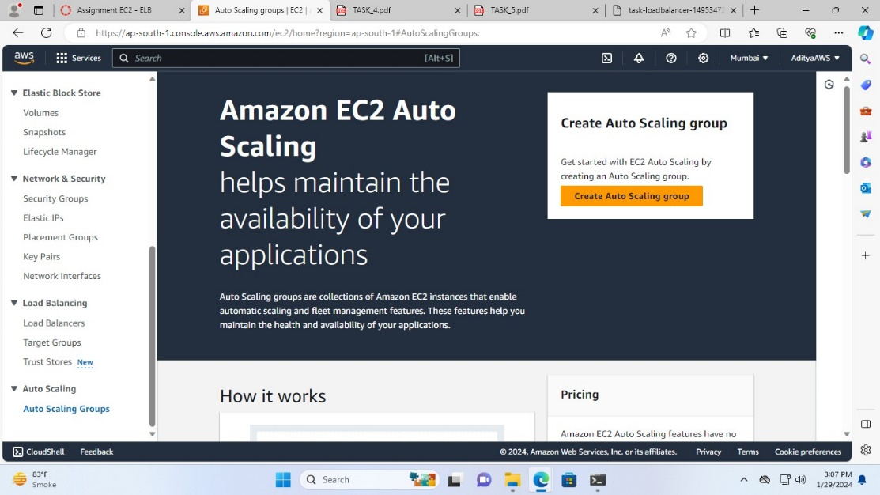

1. Name the Auto Scaling group (Task-ASG)

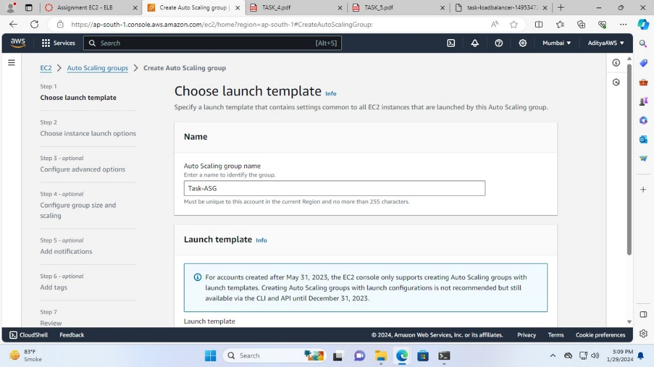

1. In the Launch template section click on “Create a launch template”

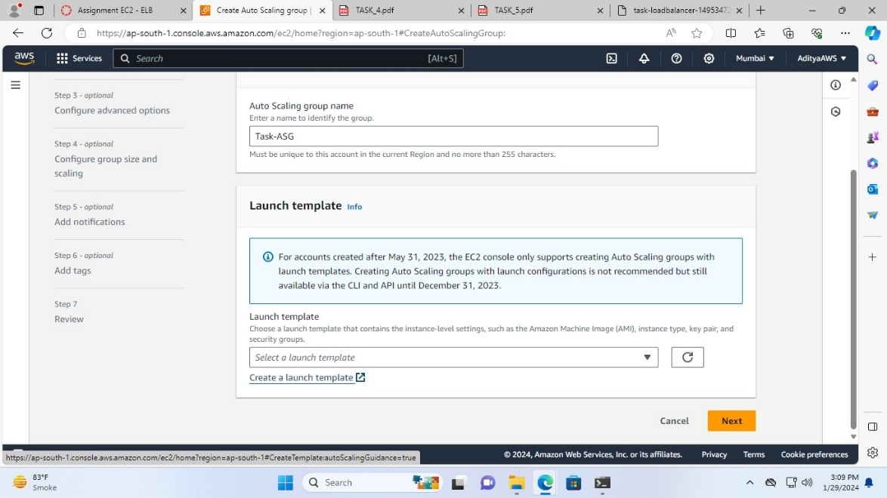

1. Name the Launch template (Task-launchtemplate)

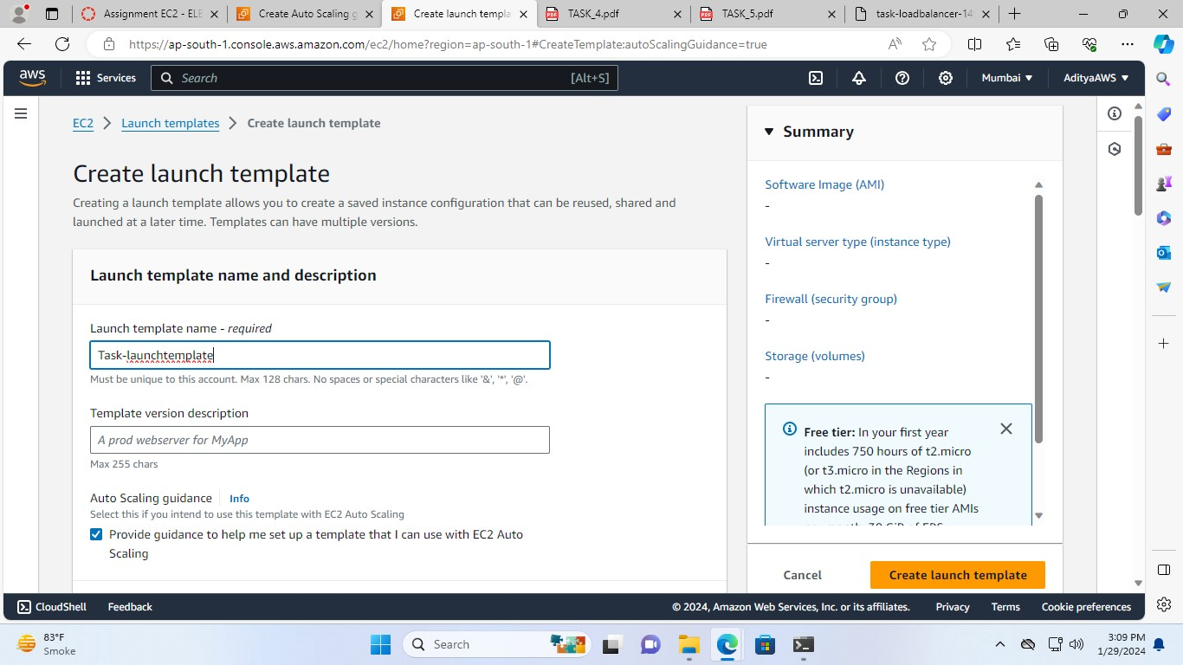

1. In the AMI section select the Amazon Linux 2 with the latest version

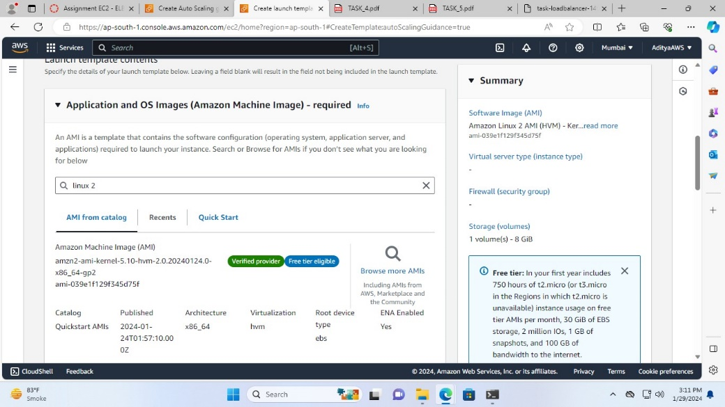

1. Choose t2.micro in the Instance type and leave the Key pair section as it is

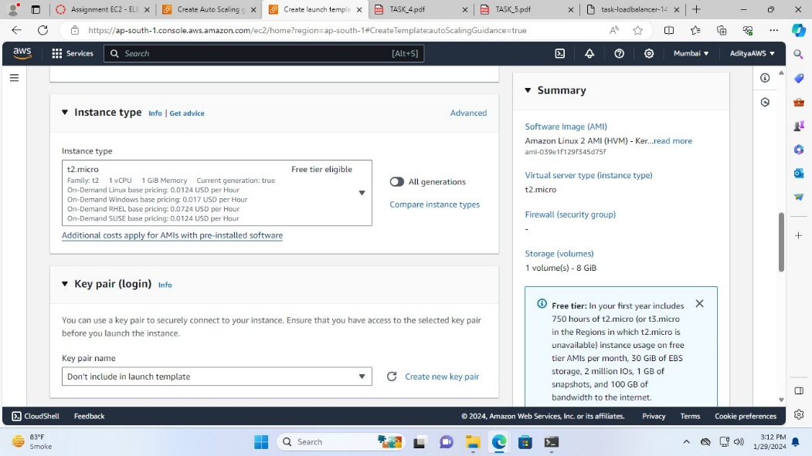

1. Then, select launch-wizard-6 from the existing security group

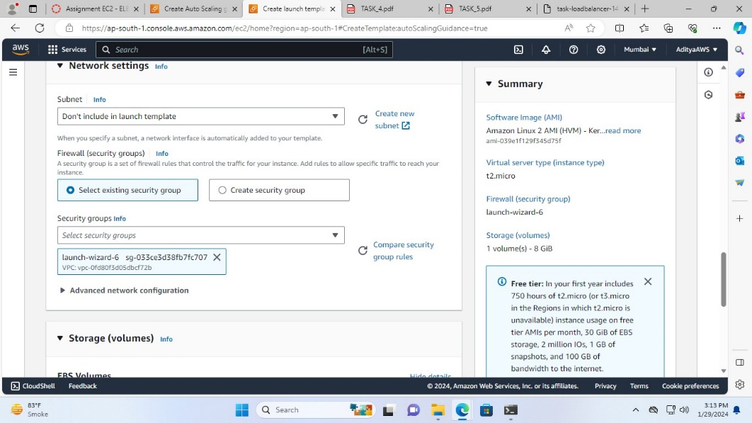

1. Now, click on “Advanced details” and in it, in the User data section add this

#!/bin/bash

yum update -y

yum install -y httpd

systemctl start httpd

systemctl enable httpd

echo ”<h1>IP ADDRESS: $(hostname -f)</h1>” > /var/www/html/index.html

then, click on “Create launch template”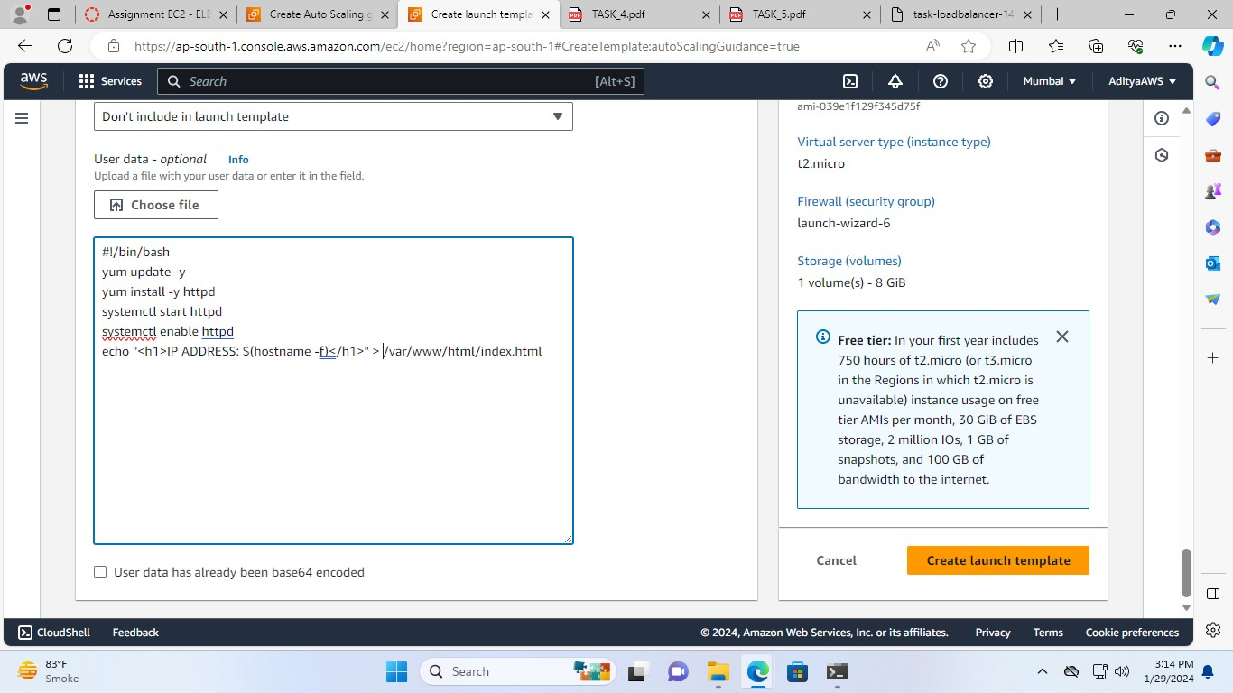

so, the launch template created successfully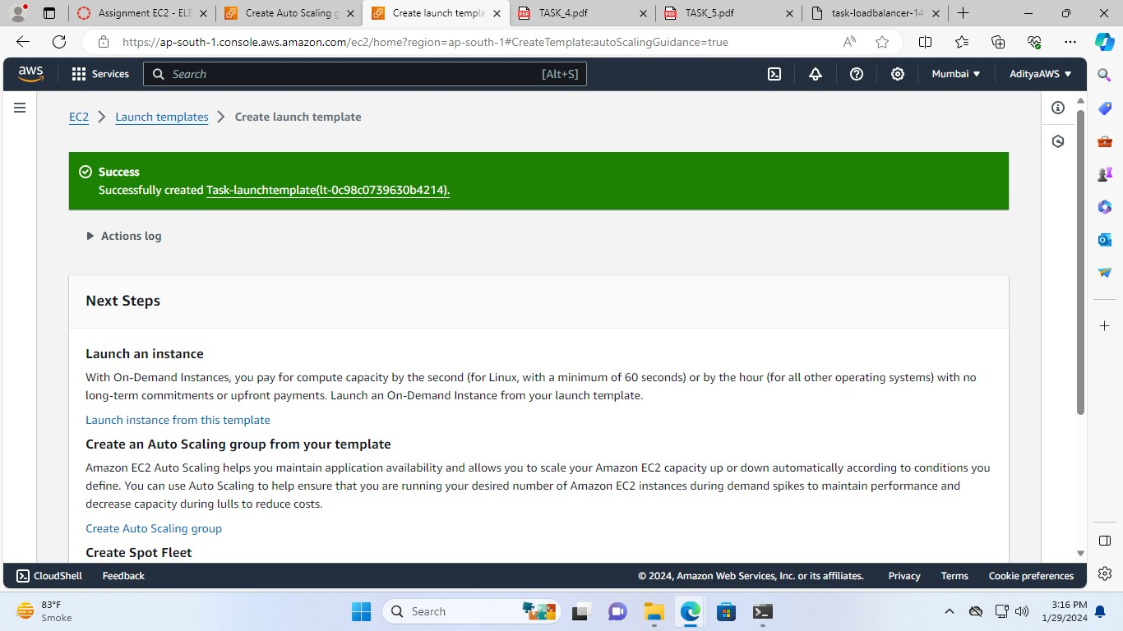

1. Select the Task-launchtemplate in the Launch template section and click “Next”

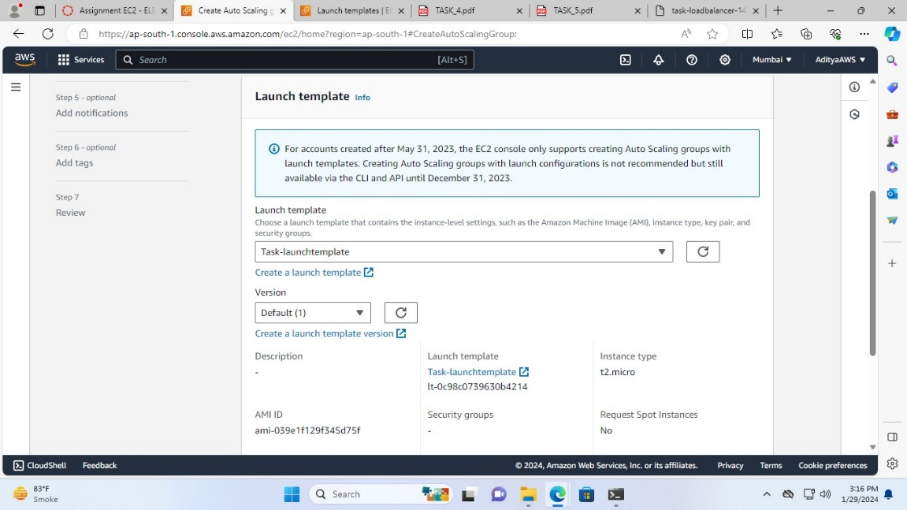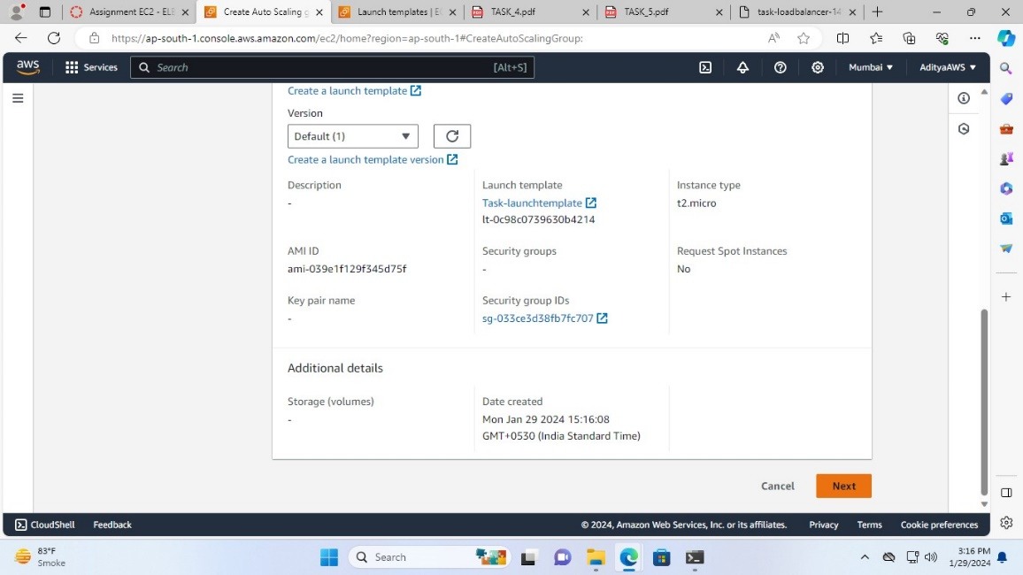

1. Select all the zones in the Availability Zones and click “Next”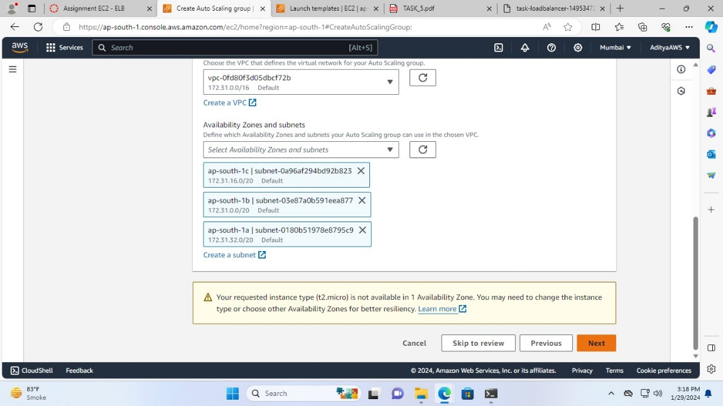
2. Now, in the Load balancing select “Attach to an existing load balancer” and choose Task-target-group in Existing load balancer target groups. Click “Next”

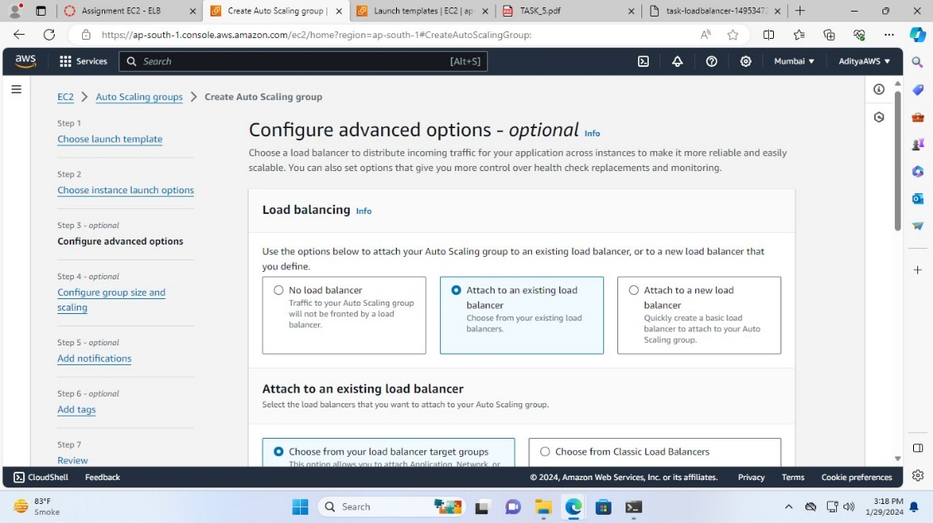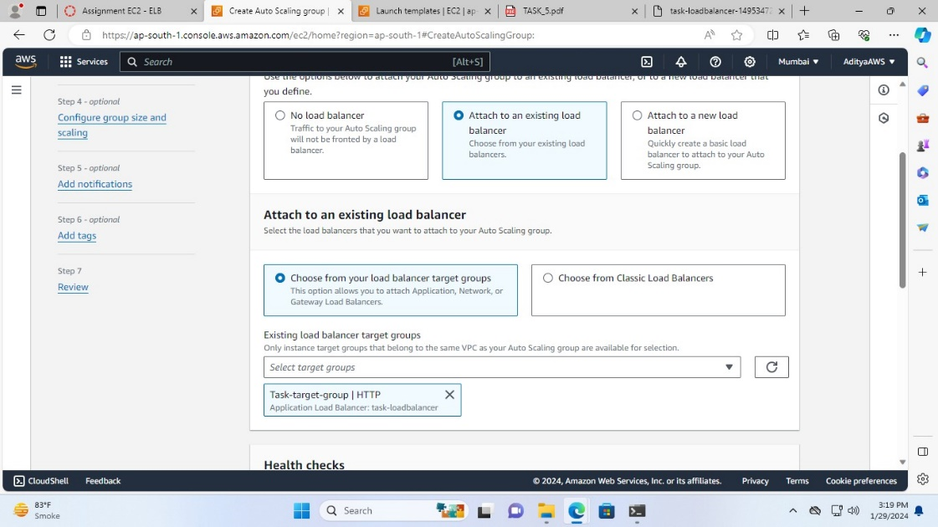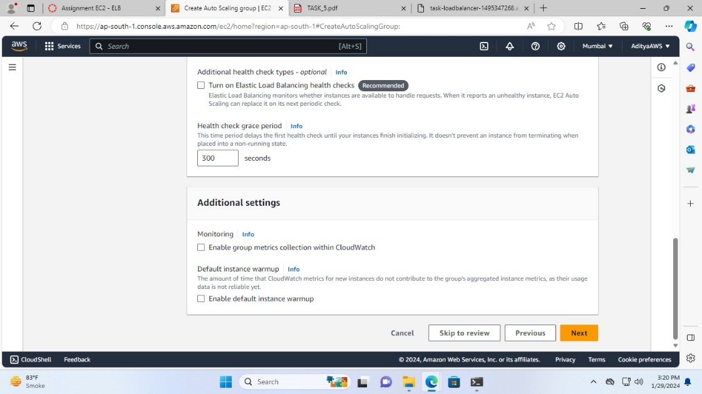

1. Now, configure group size and scaling desired capacity will be 1 and in Scaling set Min desired capacity to 1 and Max desired capacity to 2.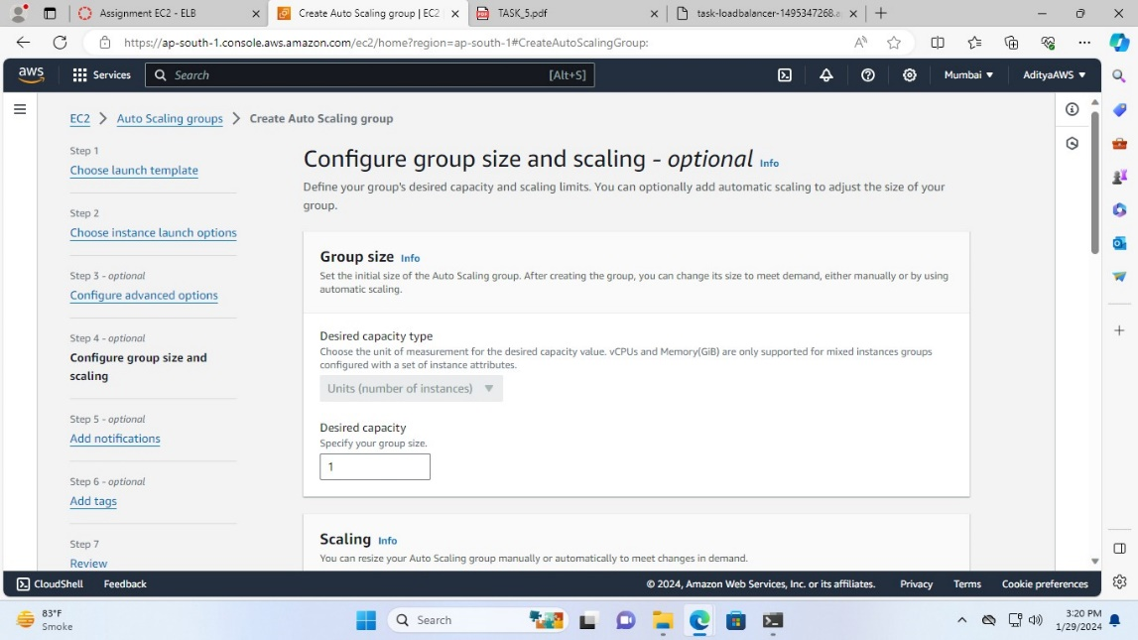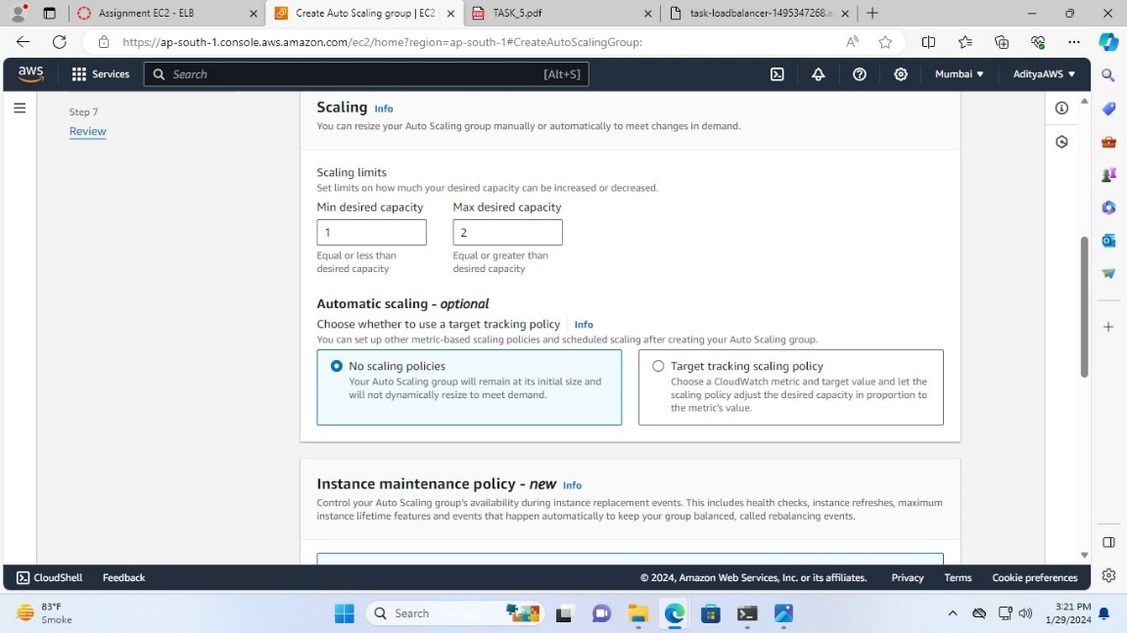

Then, click on “Skip to review”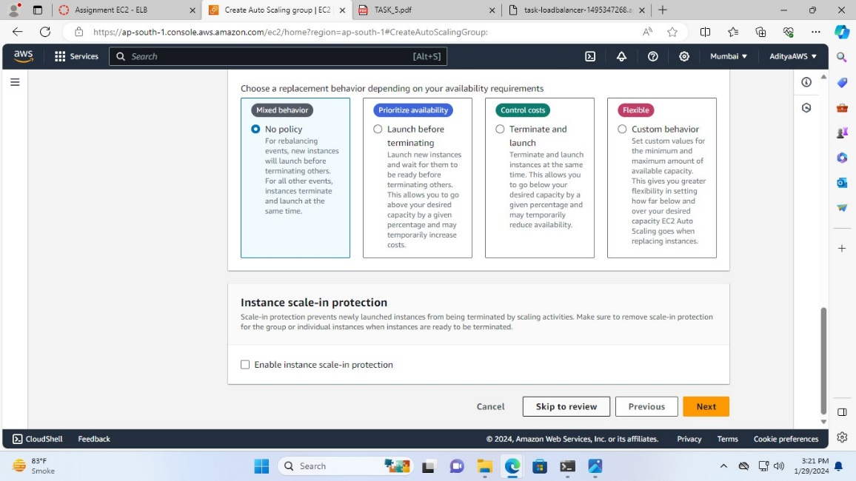

1. Click “Create Auto Scaling group”

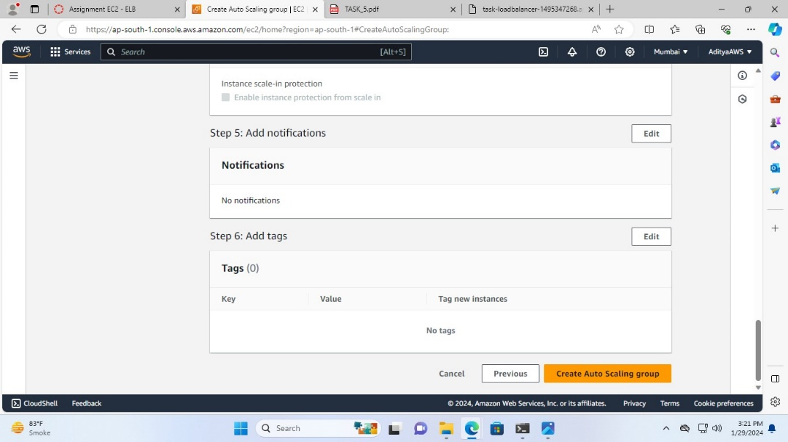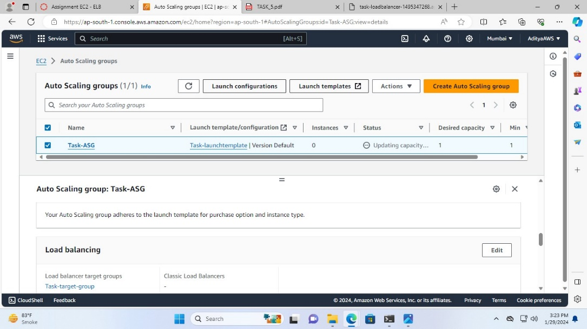

**In order to use the Stress command steps are:**

1. First go in the “Edit Task-ASG” set the Health check grace period to 10 seconds and click “Update”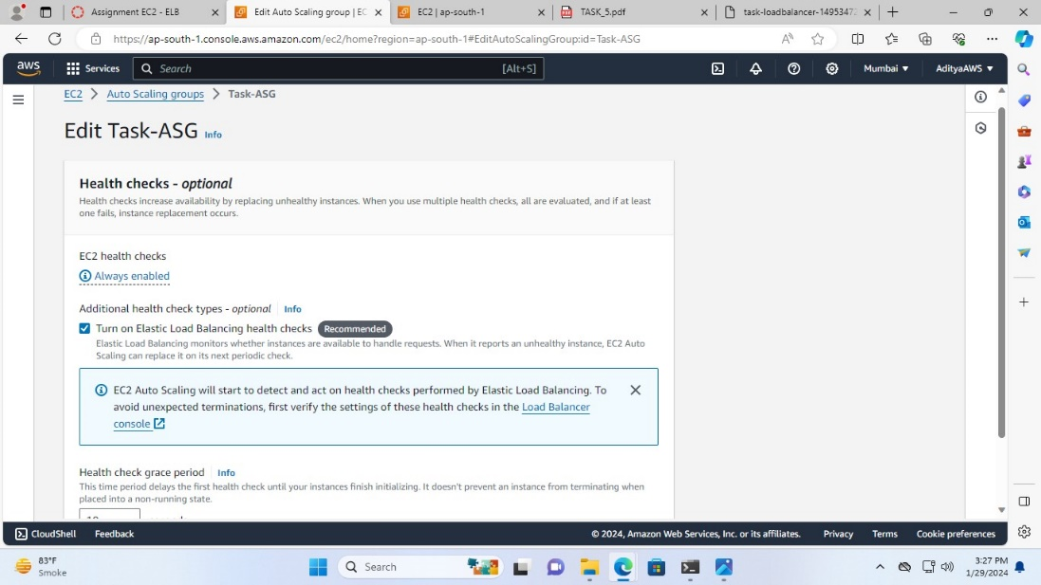

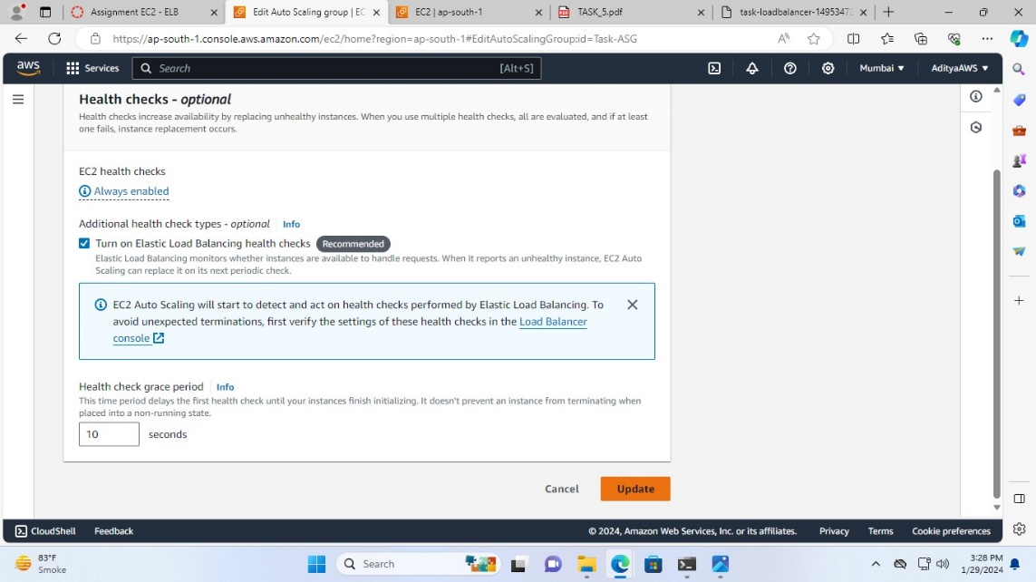

1. Now, connect the EC2 instance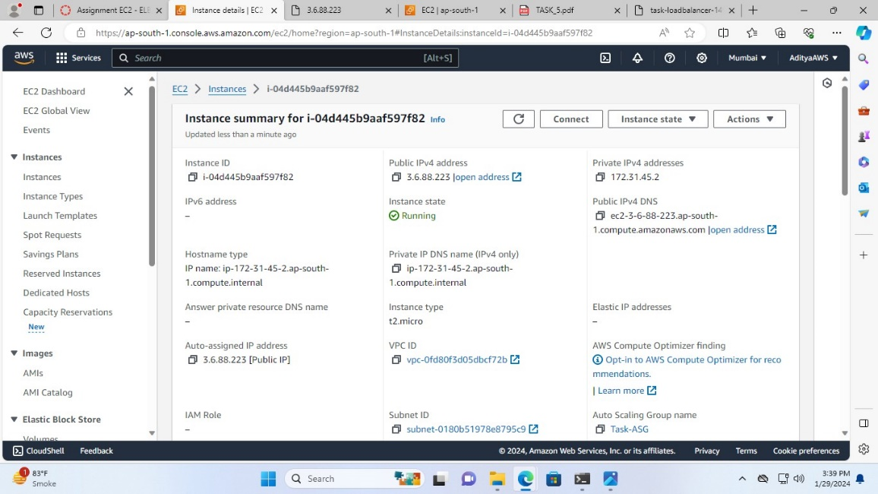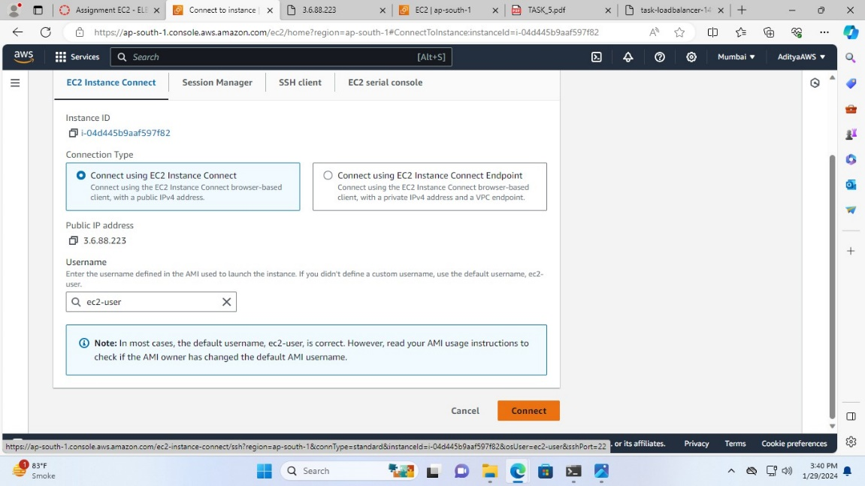

After, the connection 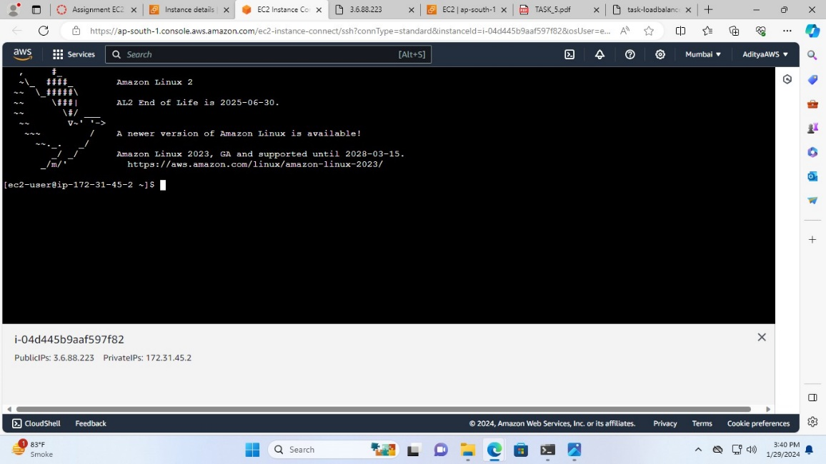

1. Now, run the command **sudo amazon-linux-extras install epel**

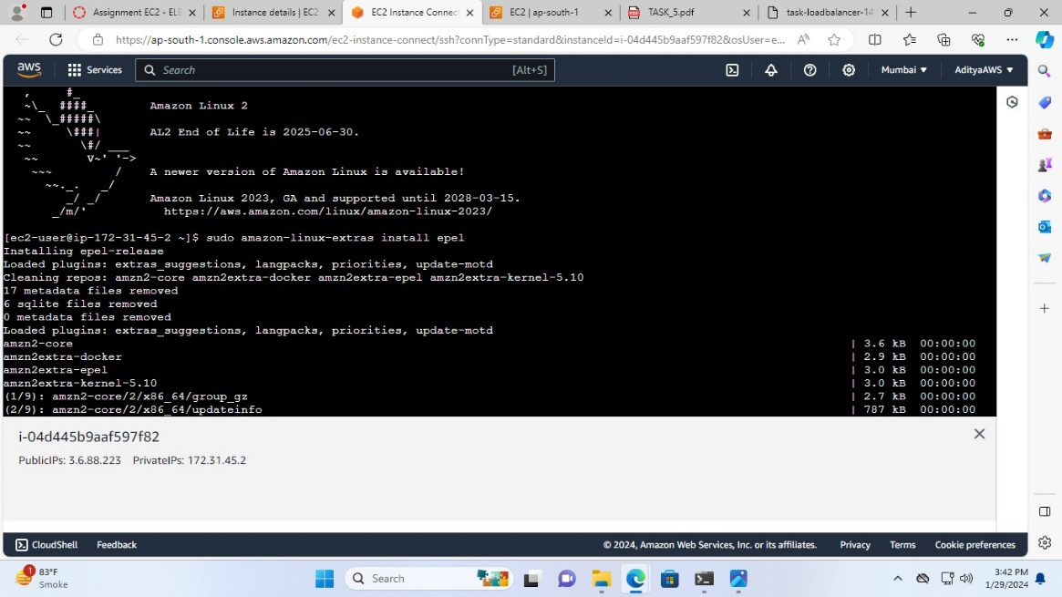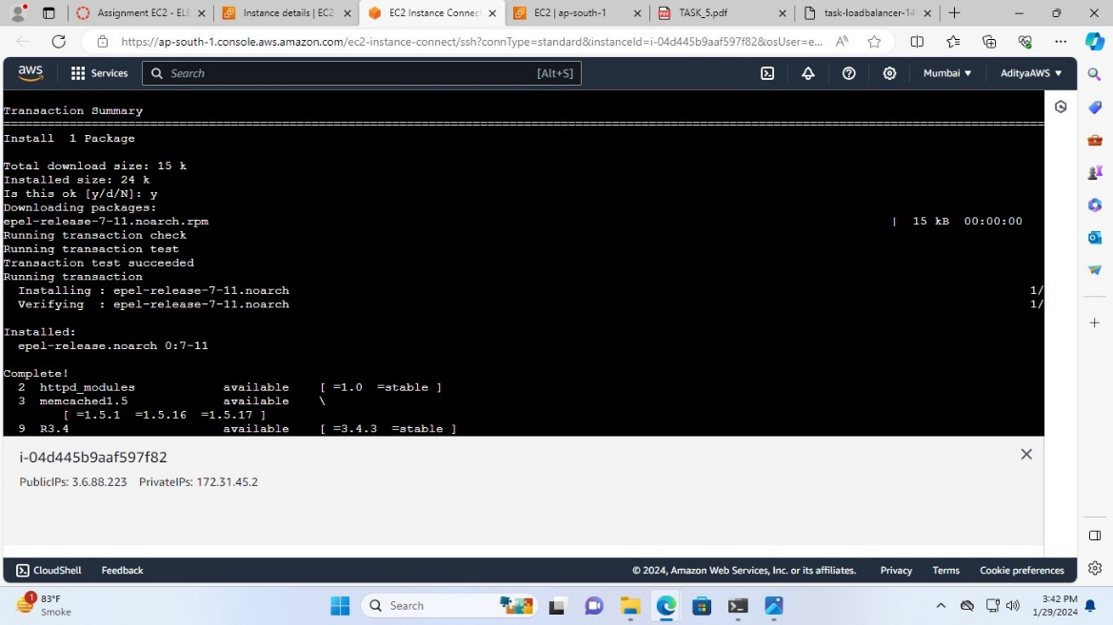

1. After, this run **sudo yum install stress**

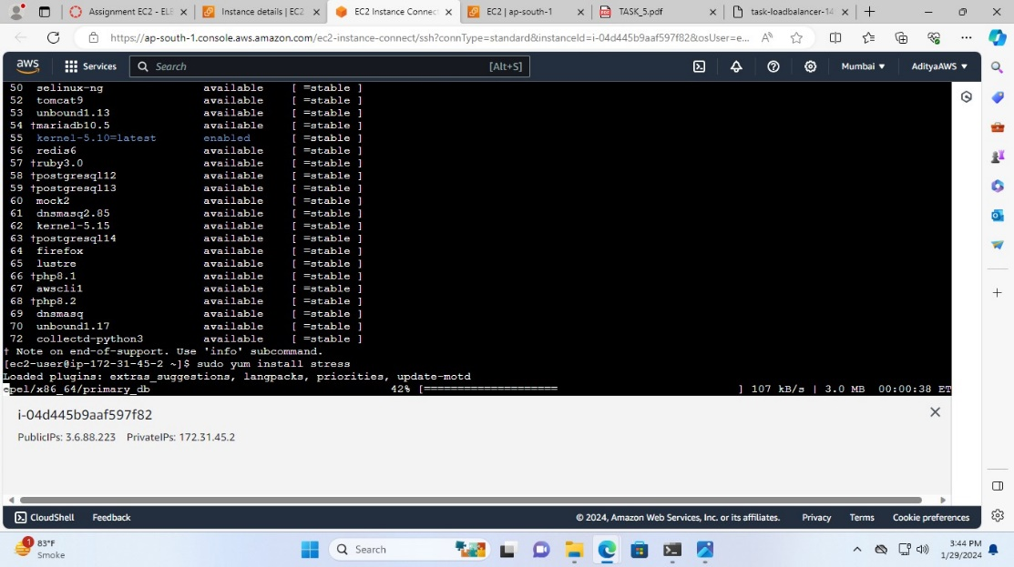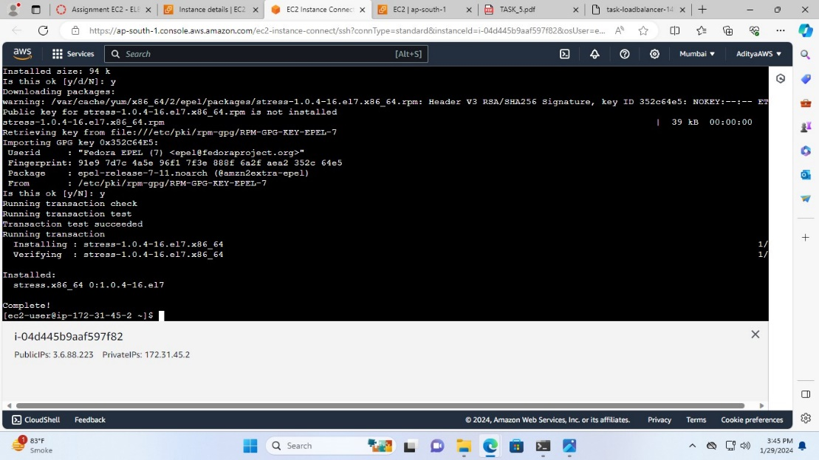

1. To use "Stress" command for increasing CPU utilization run

**sudo stress** --**cpu 1000000000000** --**timeout 120**